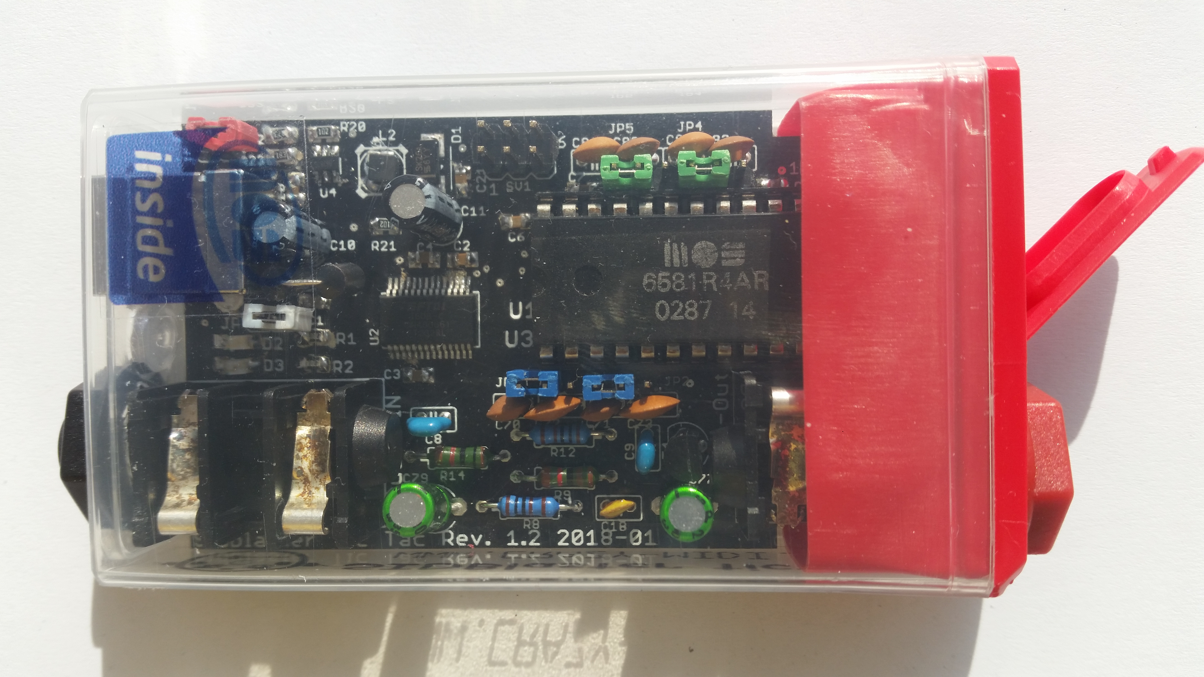

SIDBlaster-USB

Tic Tac Edition
– A real SID Chip on PC or Mac

user manual
by Andreas Schumm, Rev. 1.0

Copyright© 2021 www.crazy-midi.de
Index
1. Introduction 1
1.1 Improvements 1
2. General information 2
3. Hardware installation 3
3.1 SID-chip installation 3
3.2 Jumper settings 4
3.2.1 For the 6581 SID-chip: 4
3.2.2 For the 8580 SID-chip: 4
3.3 Other jumpers on the hardware 5
3.3.1 JP6 (White) 5
3.3.2 SV2:Paddle connector (yellow) 5
3.3.3 SV1: ISP Connector 6
3.4 USB and audio connections 6
3.4.1 USB jack 6
3.4.2 Audio-out jack 7
3.4.3 Audio-in jack 7
4. Software 7
4.1 The FTDI D2XX driver 7
4.1.1 Windows 7
4.1.2 Linux 8
4.1.3 MacOS 9
4.2 The hardsid library 9
4.2.1 Windows 10
4.2.2 Linux 10
4.2.3 MacOS 10
4.2.4 SIDBLASTERUSB_WRITEBUFFER 11
4.2.4.1 Windows 11
4.2.4.2 Linux/MacOS 11
4.2.5 The SIDBlasterTool 11
4.2.6 Notes for developers 12
4.3 Applications 12
4.3.1 Vice64 12
4.3.2 ACID64 Player 12
4.3.3 SidPlay2 12
4.3.4 GoatTracker 12
4.3.5 JSIDPlay2 12
4.3.6 Cloando’s C64 Forever 13
4.3.7 AIASS 13
4.3.7.1 sid-object for Max/MSP & Max4Live 13
4.3.7.2 AIASS – Max4Live device(s) 13
4.3.7.3 AIASS – VST 13
5. Community 14
6. Links 14
7. Thanks to 14

Introduction
The SIDBlaster-USB Tic Tac comprises premium "open-source" hardware for using a genuine "SID"-sound chip for C64 emulation, playback of SID tunes and music production as a little box on the USB port of a personal computer or Mac.
SIDBlaster-USB Tic Tac is based upon “SIDBlaster-USB“, and is 100% compatible with it.

Improvements
- Good value universal current supply 9V or 12V
- Original C64-audio wiring
- Optional connection facility for two Paddles.
- Switchable filter capacitors
- Switchable capacitors for Paddle
- Precisely fitting printed circuit board for assembly into a Tic Tac candy box
- Audio-In
- Professional 6,3mm mono audio jack sockets
- Cozy blue power LED
- (Rev.1.2:) red TX/RX-LED
- (Rev. 1.2 white jumper to connect GND and shield (experimental).
- prepared for read access (firmware 1.1)

General information

- Plug and play is not possible, the SIDBlaster must be plugged in before using in an application. Also, do not unplug the SIDBlaster before you have finished the application.
- When you are not using the SIDBlaster it is recommended to unplug the USB-connection since this prolongs the life of the SID-chip.
- Since a SID-chip produces heat, use a heat-sink on the chip if possible and make sure there is sufficient ventilation (leave the flap of the Tic Tac candy box open).

Hardware installation

SID-chip installation
Warning! Double check the voltage settings on the SIDBlaster hardware. If you set them incorrectly, for example sending 12V into an 8580 SID-chip which runs at 9V, you will destroy the chip. If you have a multi-meter, check the voltage at the SID chip socket to be sure.
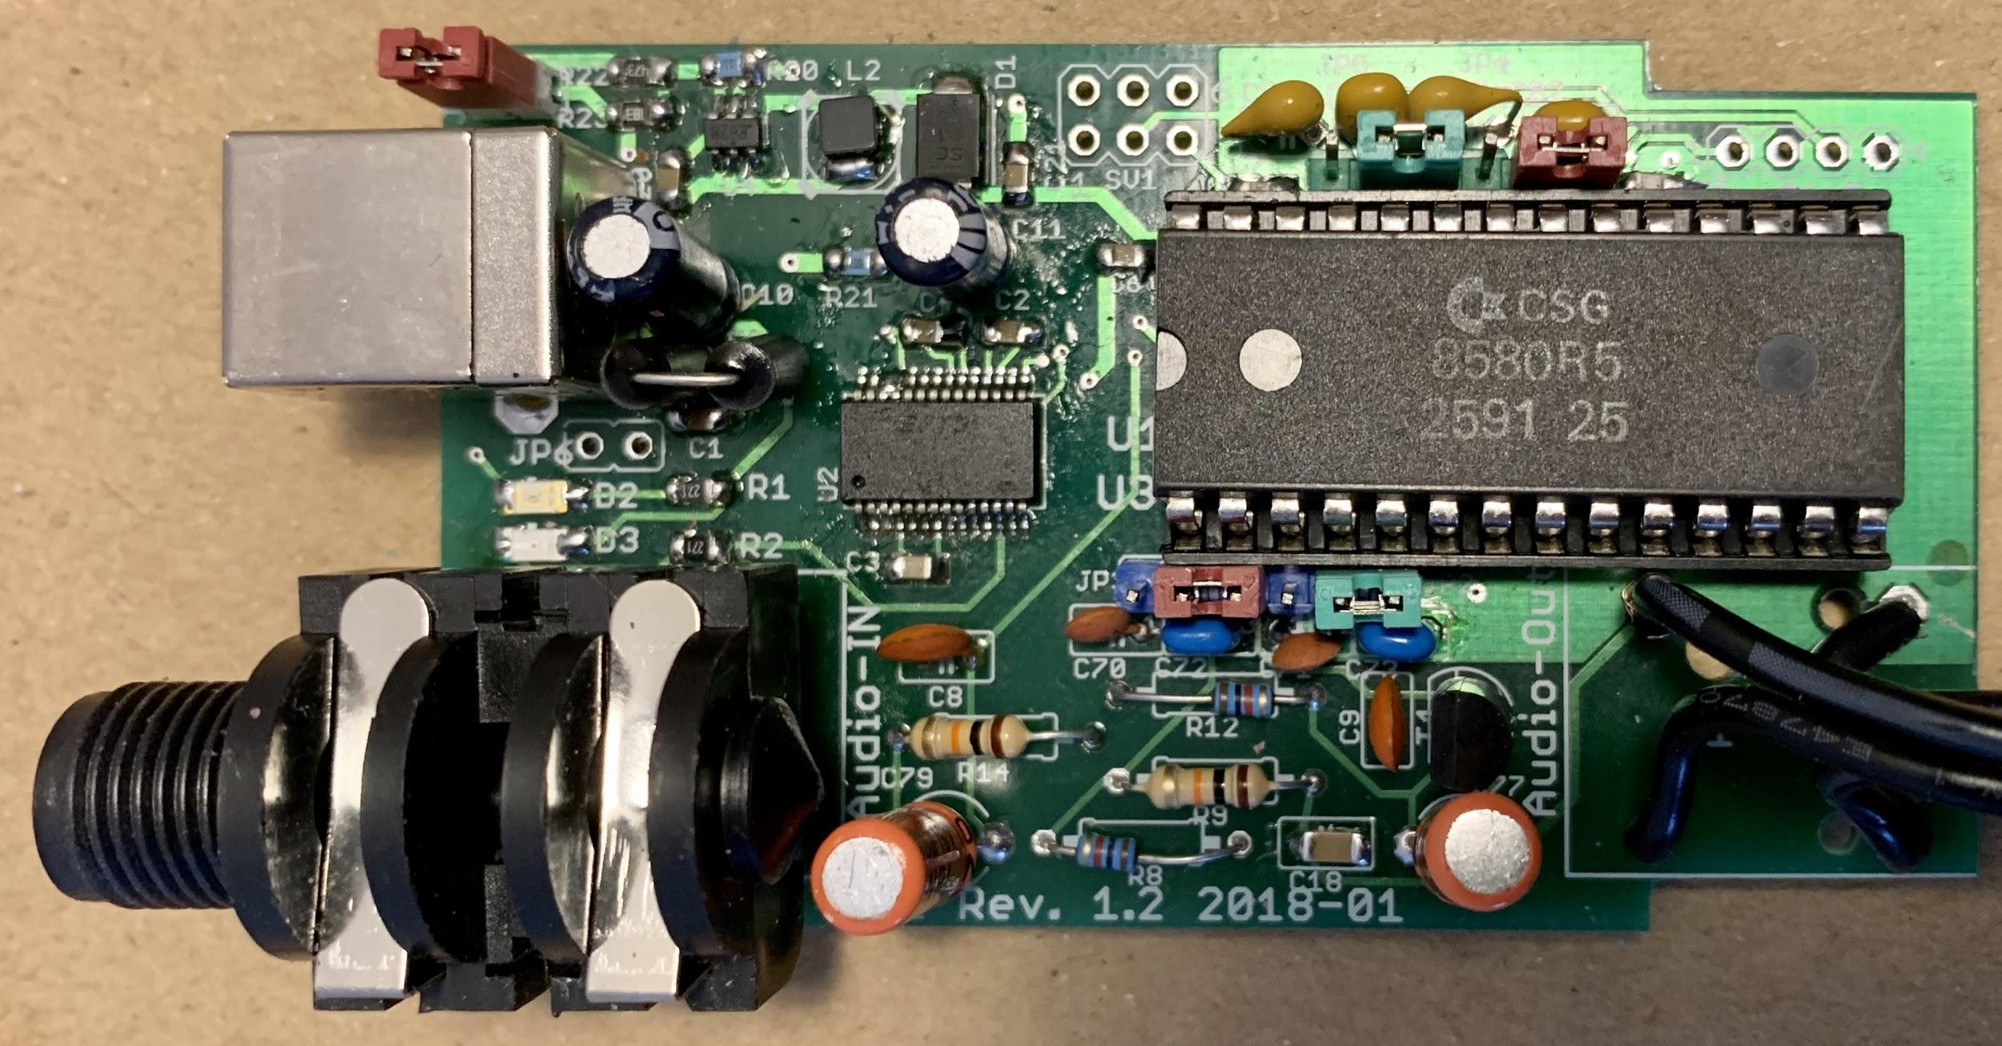A SIDBlaster-USB with correct installed 8580
Always use an anti static bracelet to avoid damaging the SID-chip and other electrical components when installing it in the SIDBlaster.
To remove a SID chip, for example, use a screwdriver, lever it out alternately, be careful not to damage the circuit board or components.
Before inserting a SID, bend the legs straight with a pair of pliers, press carefully, check that none of the legs bend over.

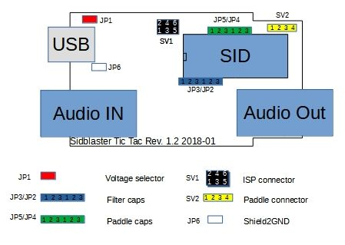
Jumper settings

For the 6581 SID-chip:
- JP1: must be open (12V).
- JP2-JP5: Place all jumpers on the left side (pins 1-2).

For the 8580 SID-chip:
- JP1: must be closed (9V).
- JP2-JP5: Place all jumpers on the right side (pins 2-3).

Other jumpers on the hardware

JP6 (White)
From Rev. 1.2 and on. Experimental, connects USB shield to ground; you may try it to counteract interfering noise.

SV2:Paddle connector (yellow)
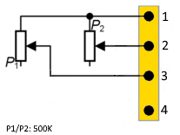
Here you have access to the two A/D converters of the SID chip. For example, you can connect 2 rotary potentiometers as paddles. This is interesting for programmers. You can also use the function with the SID object for Max/MSP.
1 | +5V
2 | POTX
3 | POTY
4 | GND

SV1: ISP Connector
Use a Picit 3 programmer to flash the microcontroller. MPLAB IPE is used as software.
1 | MCLR/VPP
2 | +5V
3 | GND
4 | PGD (ICSPDAT)
5 | PGC (ICSPCLK)
6 | n.c.

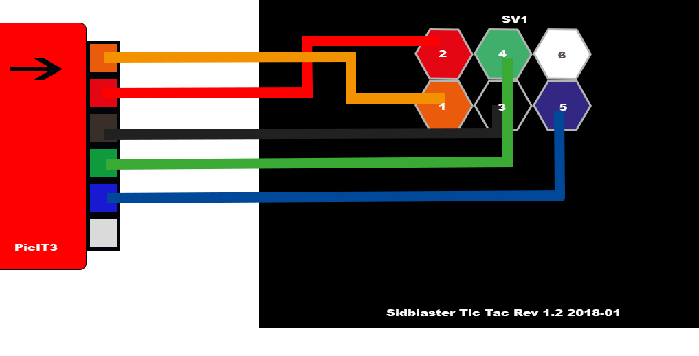

USB and audio connections

USB jack
Connect the SIDBlaster hardware to a USB port using a type A-B USB cable of good quality. It can also work with a good quality USB-hub.

Audio-out jack
The audio output is designed as a professional 1/4 "jack socket. Connect the audio output of the SIDBlaster to your mixer or audio interface using an unbalanced (mono) cable.

Audio-in jack
The second audio jack on the SIDBlaster is an audio input and is also an unbalanced connection. If you are unsure which connector is which, the connectors are marked on the PCB. Be careful about what you connect to the input of the SID-chip. These chips are old and very sensitive to electrical spikes and too high voltages.

Software

The FTDI D2XX driver

Windows
The SIDBlaster needs to do a digital "handshake" the first time it is connected via USB. This requires an internet connection. The handshake will not work if your internet connection is set to “Metered Connection” in Windows. To solve this, temporarily disable “Metered Connection”, wait a moment for the SIDBlaster to do the handshake, and then re-enable “Metered Connection”.
The SIDBlaster is recognized by Windows as a “USB Serial Converter”. It may be recognized as a COMx device with ports (in Device Manager). Edit: Your SIDBlaster have to be flashed correctly with the FTDI prog tool and the template from the SIDBlaster project in this case. The actual hardsid.dll don't accept incorrect flashed SIDBlasters. With older versions of Windows, installation of a driver by FTDI may be necessary, available at: http://www.ftdichip.com/Drivers/D2XX.htm.

Linux
Download D2XX driver from: https://ftdichip.com/drivers/d2xx-drivers/
Please install FTDI drivers explained in chapter '2 Installing the D2XX driver' from here: https://www.ftdichip.com/Support/Documents/AppNotes/AN_220_FTDI_Drivers_Installation_Guide_for_Linux.pdf
If device still cannot be used, please install a workaround mentioned in chapter '1.1 Overview' :
$ sudo vi /etc/udev/rules.d/91-sidblaster.rules
ACTION=="add", ATTRS{idVendor}=="0403", ATTRS{idProduct}=="6001", MODE="0666", RUN+="/bin/sh -c 'rmmod ftdi_sio && rmmod usbserial'"
$ sudo udevadm control --reload-rules && udevadm trigger

MacOS
Note: it may be necessary to switch off the security monitoring in MacOS or to authorize all developers.
sudo spctl –master-disable
Could also work:
sudo xattr -rd com.apple.quarantine / Your software path.app
Download and install D2XX Driver from: https://ftdichip.com/drivers/d2xx-drivers/
use the instructions from: https://ftdichip.com/wp-content/uploads/2020/08/AN_134_FTDI_Drivers_Installation_Guide_for_MAC_OSX-1.pdf
Download and install D2XXHelper from the same site.

The hardsid library
Is the “driver” of the SIDBlaster, so to say. Under windows it comprises a reprogrammed DLL of the Hardsid, thus, software programmed for the Hardsid becomes compatible for the SIDBlaster. Later the DLL was ported to linux and macos. The DLL is made and maintained by Stein Pedersen. Linux/Mac port was made by Ken Händel.

Windows
- Download from:
https://github.com/gh0stless/SIDBlaster-USB-Tic-Tac-Edition/tree/master/hardsid_library
- Copy the right hardsid.dll into the program directory of the program with which you want to use it.
- The 64 bit version is required by the 64 bit version of vice and also by the 64 bit versions of AIASS.

Linux
- Download from:
https://github.com/gh0stless/SIDBlaster-USB-Tic-Tac-Edition/tree/master/hardsid_library
- copy libhardsid.so to /usr/local/lib/
- apply chmod 0755 on libhardsid.so
- copy hardsid.hpp to /usr/local/include/

MacOS
- Download from:
https://github.com/gh0stless/SIDBlaster-USB-Tic-Tac-Edition/tree/master/hardsid_library
- copy libhardsid.dylib to /usr/local/lib/
- copy hardsid.hpp to /usr/local/include/

SIDBLASTERUSB_WRITEBUFFER
Depending on your system, tunes with high data rates (multi speed tunes or digitunes) may play slower if the latency of the USB driver is too high. This can be remedied by setting the driver write buffer size to a larger value, for instance. Even down to 0, works on fast machines.

Windows
set SIDBLASTERUSB_WRITEBUFFER_SIZE=8

Linux/MacOS
export SIDBLASTERUSB_WRITEBUFFER_SIZE=8

The SIDBlasterTool
With SIDBlasterTool you can check if library and device communication works.
You can also set the SID type and change the serial number. The type is saved as part of the device description and evaluated by applications such as JSIDPlay.

Notes for developers
For developers who want to write applications using the hardsid library, I refer to hardsid.hpp. You can find a few more tips in the AIAS-VST repository in the doc folder. Do not forget to call the destructor method manually when exiting under MacOS and Linux.

Applications

Vice64
The famous C64 emulator supports up to 3 SIDBlasters. In the simplest case, you now have a C64 with original sound. But you can also use the SIDBlaster with Vice64 as a MIDI expander, by activating the MIDI emulation, and load a synthesizer program like Station64. Only Windows.

ACID64 Player
Best SIDBlaster support, if you have several devices you can even play stereo and 3SID tunes. Only Windows. Version 4 no longer supports the SIDBlaster.

SidPlay2
Good SID player, suitable as a jukebox because of playlists. Only Windows.

GoatTracker
Tracker. Only Windows.

JSIDPlay2
JSIDPlay2 is a fantastic C64 content media player. In the current version it has the best SIDBlaster support. It may not be as handy as ACID64, but once you have familiarized yourself with it, it is a very powerful and comprehensive program. Available for Windows, MacOS and Linux.

Cloando’s C64 Forever
Also compatible. Just copy the hardsid.dll in the folder of Vice. Then, enter"-sidenginemodel hardsid" in the option „custom parameters“. C64 Forever is Windows Only.

AIASS
AIASS Is A SID Synthesizer

sid-object for Max/MSP & Max4Live
Is a Max/MSP C-external for the SIDBlaster-USB

AIASS – Max4Live device(s)
The AIASS for MAX4LIVE project is a set of max4live devices to control one or more SIDBlaster-USB as a synthesizer application. This makes it possible to produce music with an original SID chip MOS 6581 or MOS 8580 from the Commodore 64, in a modern DAW.

AIASS – VST
A simple VST, which is still very rudimentary.

Community
Meet us on Facebook in our Facebook group for discussion and news. („SIDBlaster-USB“ on Facebook)

Links
- http://crazy-midi.de/
- https://github.com/gh0stless/SIDBlaster-USB-Tic-Tac-Edition
- https://github.com/gh0stless/SIDBlasterTool
- https://github.com/gh0stless/sid-object
- https://github.com/gh0stless/AIASS-for-MAX4LIVE
- https://github.com/gh0stless/AIASS-Mono-VST
- https://github.com/Galfodo/SIDBlasterUSB_HardSID-emulation-driver
- https://vice-emu.sourceforge.io/
- https://www.acid64.com
- http://www.gsldata.se/c64/spw/ (SIDPlay2)
- https://haendel.ddns.net/~ken/ (JSIDPlay2)
- https://sourceforge.net/projects/goattracker2/
- https://www.facebook.com/groups/2305052182957954/

Thanks to
- Davey (The Phantom) for creating the original SIDBlaster.
- Stein Pedersen for assistance and the sidblaster.dll.
- Wilfred Bos for his ACID Player and tips and helping.
- Ken Händel for his JSIDPlay2 and his work on the library
- Karl-Werner Riedel for his help with designing the Tic Tac hardware.
- Magnus Hansson for writing some original parts of this manual.
- Borjana Konstantinowa for her patience with me.
Coswig, Saxon 2021-06-11

